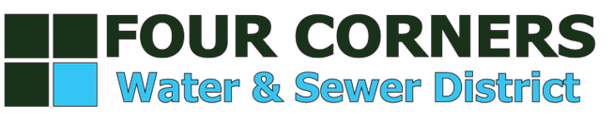
Agenda for Tuesday October 16, 2018 @ 6:30pm Monforton School Cafeteria, 6001 Monforton School Road, Bozeman, MT 59718
- Call to Order
  - Approval of Draft Meeting Minutes September 18, 2018
  - Approval of Draft Special Meeting Minutes September 25, 2018
  - Public Comment: Non-Agenda Items

General Business

1) Korner Klub Ordinance 2018-06 – 2nd reading

- Water- Change of Rate for Volume use
  - Public Comment

- Resolution 2018-16
  - Public Comment

- Sewer- Establish rate for Volume Use
  - Public Comment

- Resolution 2018-17
  - Public Comment

- Special Assessment Equalization Rate- Applies to all properties annexed into District after 12/13/2015
  - Public Comment

- Resolution 2018-18
  - Public Comment

- Water Reserve Rate Resolution 2018-19
  - Public Comment

- Sewer Reserve Rate Resolution 2018-20
  - Public Comment

- Next Meeting Tuesday December 18, 2018
- Adjourn Meeting

